**Reply Letter**

Jan. 31, 2016

Dear Editor:

Thank you for your letter dated Jan. 12, 2016 and your comments of the paper entitled “An approach to achieving optimized complex sheet inflation under constraints” for the Journal of Computers & Graphics. The paper has been carefully revised in order to accommodate the reviewers’ suggestions and comments. New figures and paragraphs are added to the introduction section to explain some concepts (sheet, dual operations, quad set etc.), the importance of sheet inflation, and the motivation of our works. Many sentences are revised according to the reviewers’ comments. A new example of Stanford Bunny is also added to Section 6.1. The following is a point-by-point response/revision summary:

**For Reviewer 1:**

***Comment 1.1****:*

*Fix the abstract. For example, start the abstract with something like "Sheet inflation is an enhanced and more general version of the classic pillowing [reference] procedure used to modify hexahedrdal meshes. The flexibility of sheet inflation makes it a valuable tool for hex mesh generation, modification and topology optimization. However, it is ..." This will give the reader some immediately context as to what.*

**Response**:

Thank you for your comments. The abstract has been revised and the reference of pillowing has been added.

***Comment 1.2:***

*On line 15 of the introduction, add a reference to staten's work on sheet inflation. Also add references for sheet extraction, dicing and column collapsing on this line. Also add pillowing to this line.*

**Response:**

The references have been added. Meanwhile, to help readers understand what dual operations are, a new figure has been added which illustrates the procedures of these dual operations:

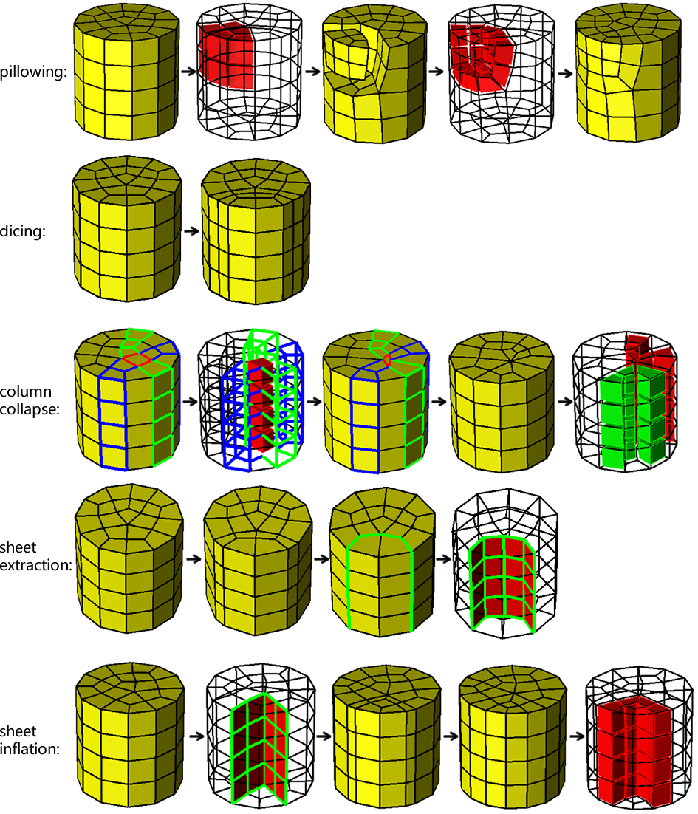

Comment 1.3:

*Fix Figure 1:*

*3A. Figure 1 and 2 are basically duplicates of each other. There is no need for both. Consolidate them into a single figure.*

*3B. Figure 1 is very small, and difficult to visualize. Make this figure bigger.*

*3C. Choose a different color scheme on Figure 1A, so you have more contrast. Currently it is black mesh edges on dark grey quads, makes it difficult. How about black mesh edges on yellow.*

*3D. Add a Figure 1D, which shows the mesh in full-shaded just like figure 1A, but after the sheet is inserted. Figure 1C is difficult to understand.*

**Response:**

These two figures are used to show what sheet inflation is and how the constraints impact on the sheet inflation. In this revision, the procedures of sheet inflation are introduced in Figure 2, and how the constraints impact on the sheet inflation is explained in three new figures (Figure 3, Figure 4 and Figure 5). Hence these two figures are removed.

**Comment 1.4:**

*Add a paragraph with some text which describes what sheet inflation is. Currently all you say is "The common procedures of sheet inflation are shown in Fig. 1". Add a full paragraph that describes what a quad set is, how it compares to pillowing, etc. Because sheet inflation is the back-bone of your paper, the reader needs to understand what it is without having to go searching for references.*

**Response:**

To explain clearly what sheet inflation is, we illustrate the procedures of sheet inflation in Figure 2. We also add a new paragraph in the introduction to describe what sheet inflation is as well as what the quad set for sheet inflation is and why it is important:

“

Sheet inflation can be seen as the reverse of sheet extraction, which “inflates” a continuous quad set into a new sheet. As shown in Fig. 2, it splits the nodes, edges and quads on the quad set, and then form new hexahedra by connecting corresponding the new nodes. There fore, the quad set is critical for sheet inflation because it determines the position, shape and topology of the sheet to be generated. Since topologically any sheet can be extracted (though sometimes extraction may not be possible due to geometrical restrictions), sheet inflation has the potential ability to create any kind of sheets, provided that a suitable quad set are determined.

”(Sec. 1)

**Comment 1.5:**

*You mention "the quad set" in the caption of Figure 1, but have not introduced it.  Explain why a quad set is needed for sheet inflation, and where it comes from.*

**Response:**

The notion of quad set comes from sheet extraction. As the sheet inflation can be seen as reverse of sheet extraction, and sheet extraction extracts a sheet and results in a continuous quad set, therefore sheet inflation needs a quad set from which the new sheet can be inflated. To explain why a quad set is needed for sheet inflation and where it comes from, we illustrate the procedures of sheet extraction and sheet inflation in Figure 2 and add a new paragraph to explain the relationship between sheet inflation, sheet extraction and the quad set. Please refer to the response for Comment 1.4.

**Comment 1.6:**

*The introduction currently contains no motivation for why the reader will care about sheet inflation. Add some description about what it is used for so the user will understand "why" we need sheet inflation to work better for self-intersecting sheets.*

**Response:**

To explain our motivation clearly, we first provide an example at the beginning of introduction in Figure 1, showing why dual operations are useful for hexahedral mesh modification. Then we explain that sheet inflation is quite versatile to create various sheets for different mesh modification, and provide a real example to show how sheet inflation can be utilized to effectively modify the hexahedral mesh boundary in Figure 3, 4 and 5. And then we also give another example in Figure 6 when self-intersecting sheets are needed to be inflated in order to reduce the high valence. The new paragraphs and figures are shown below:

“

Due to the versatility to create various sheets, it is very promising to utilize sheet inflation in many mesh modification scenarios. One common scenario is to use sheet inflation to lo- cally change the mesh topology, especially the boundary topol- ogy. To meet the modification requirements, new sheets need to be created at the specified position within a delimited region. As the quad set plays a key role for sheet inflation, the main difficulty to achieve this is how to construct a qualified quad set under the user’s constraints. In practice, these constraints are usually specified by a set of boundary edges and a set of hexa- hedra. The former determines the positions where the new sheet should appear on the mesh boundary, and the latter delimits the region where the new sheet can propagate.

Figure 3 shows an example when such constrained sheet in- flation is required. Node valences (the number of adjacent edges of a node) and edge valences (the number of adjacent faces of an edge) are important quality metrics for quad meshes and hex meshes respectively, and high valences usually lead to poor mesh quality [12, 13, 14, 15]. Although valences of 5 are relatively acceptable, valences equal to or higher than 6 are usually considered to be undesirable. The hex mesh (Fig. 3a) contains one boundary node whose valence is 6. This high va- lence can be reduced by splitting the node into two nodes with lower valences as shown in Fig. 3b.

A new sheet needs to be created due to the global connec- tivity of hex meshes. To specify the position of the new sheet, two mesh edges adjacent to the high-valence node are selected as constraints(Fig. 4a). Then a quad set is constructed (Fig. 4b) and the new sheet is inflated (Fig. 4c)). The high valence has been reduced as shown in Fig. 4e.

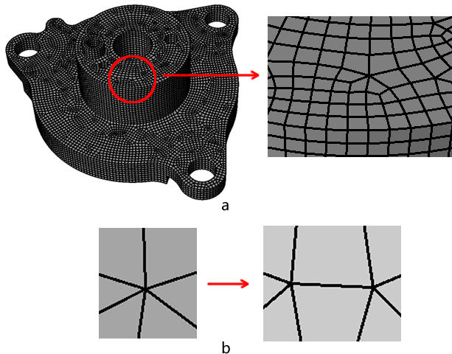

Figure 3: An example when boundary modification is required: (a) the hex mesh with a high-valence node; (b) the high valence is reduced by splitting the node into two nodes.

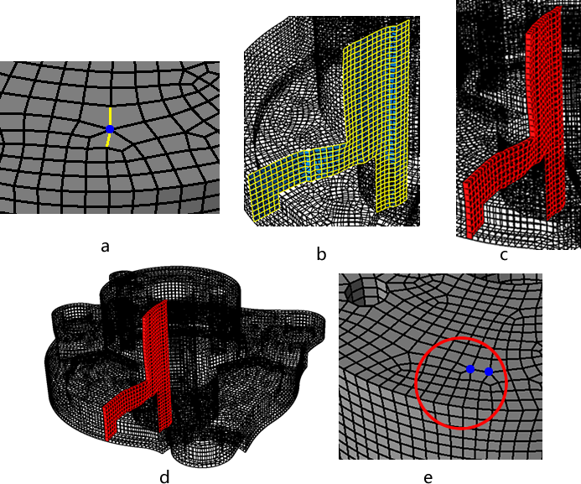

Figure 4: Reducing high valence by non-localized sheet inflation : (a) selected mesh edges where new sheet needs inflating; (b) the quad set for sheet inflation without local consideration; (c) the new sheet; (d) the high valence is improved.

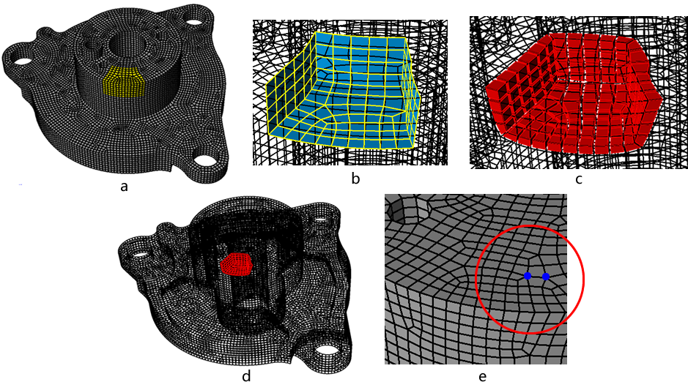

Figure 5: Reducing high valence by non-localized sheet inflation : (a) selected mesh edges where new sheet needs inflating; (b) the quad set for sheet inflation without local consideration; (c) the new sheet; (d) the high valence is improved.

…

Despite these achievements, to inflate complex sheets un- der various constraints, especially to generate self-intersecting sheets within a local region, is still very difficult. However, in many situations it is needed to locally create self-intersecting sheets. For example in Fig. 6a, when the node’s valence is 7, splitting method in Fig. 3b will not effectively reduce the high valence since one of the new nodes still has a high valence of 6 (Fig. 3b). Instead of selecting two adjacent edges, four adja- cent edges are selected and the node is splitted into four nodes as shown in Fig. 3c, which requires a self-intersecting sheet be generated. Furthermore, how to assure the mesh quality for complex sheet inflation is also a challenging problem.

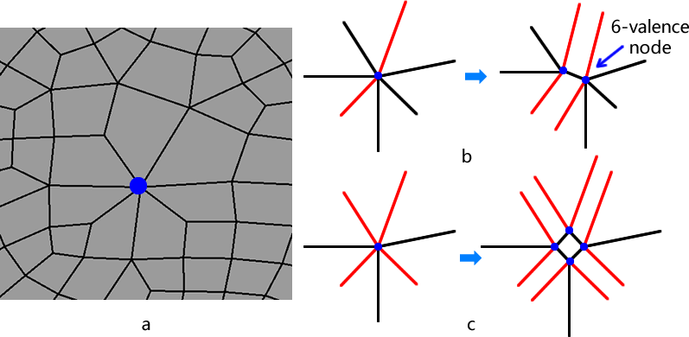

Figure 6: An example when a self-intersecting sheet is required to be generated: (a) the hex mesh with a high-valence node; (b) the high valence is reduced by splitting the node into four nodes.

”(Sec.1)

**Comment 1.7:**

*Figure 3 again is too small. In every paper I've read from these authors, their figures are too small. Why can't Figure 3 be 2 rows, rather than 1*

**Response:**

Figure 3 has been revised as below:

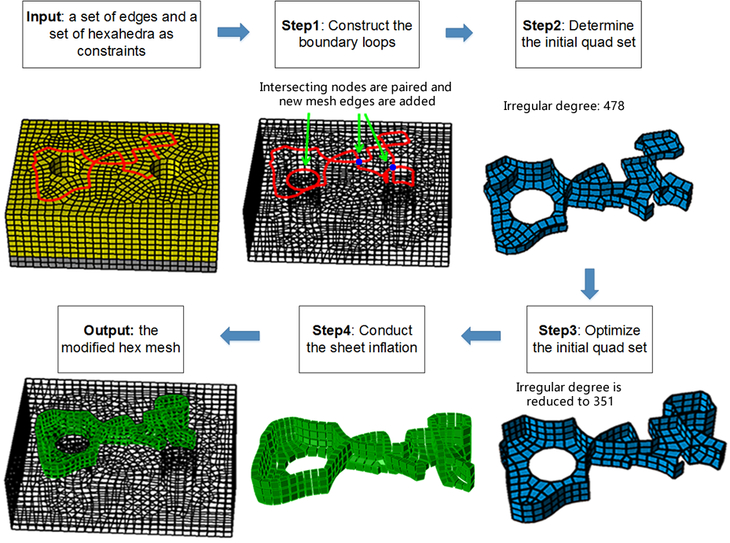

**Comment 1.8:**

*Figure 3-Step 1 mentions a "set of hexahedra as constraints" but there is no explanation as to where this set comes from. Why not use all the hexes in the mesh?*

**Response:**

The hexahedra set is used to delimit the region where the new sheet can propagate. In the example of using sheet inflation to reduce high node valence, we provide two different sheet inflation results in Figure 4 and 5. The former contains no region constraints while the latter is specified the region constraints. Comparing the two results, it can be seen that after specifying the region by a set of hexahedra, the new sheet is guaranteed to be within that region and not impact the rest of the mesh, effectively making the sheet inflation local to the whole mesh.

**Comment 1.9:**

*Line 50-51: "... makes Pillowing prevailing ..." should be "... makes Pillowing prevalent ..."*

**Response:**

The sentence has been revised according to your suggestion.

**Comment 1.10:**

*Line 85, what boundary loop? You haven't defined this yet.*

**Response:**

The boundary loop is the mesh edges that the quad set intersects with the hexahedral mesh boundary. We add a sentence to explain this:

“… For a quad set, the mesh edges where it intersects with the mesh boundary form the quad set’s boundary loop/loops….” (Sec.1)

**Comment 1.11:**

*I had to stare at Figure 6 for a very long time (5-10 minutes) before I understood it. Can you simplify this, or add more explanation text? I still don't understand what you mean by "template" in this context. Do you mean "cases" instead of template?*

**Response:**

Sorry for not explaining it clear. We have revised that part. We now use “local intersecting structures” instead of “template”, and the revised paragraphs and figure captions are below:

“…

Based on the observation of the structures of quadrilateral sets, we introduce two local intersecting structures that can be used to pair intersecting nodes. By recursively searching these two local intersecting structures on input the boundary mesh edges, a proper pairing between intersecting nodes can be achieved.

On various intersecting quad sets, two local intersecting quad subsets are commonly observed which are shown in Fig. 10(a) and Fig. 10(f). These two quad subsets both have one intersect- ing line and two intersecting nodes on their boundary loops. The topological structures of their boundary loops are shown in Fig. 10(d) and Fig. 10(i). Conversely, if a local intersecting structure of the mesh edges is found to share the same topology with either Fig. 10(d) or Fig. 10(i), there should be a corre- sponding local intersecting quad subset. Hence, it is reasonable to pair the two intersecting nodes on this local part of the mesh edges, which will not result in improper pairing mentioned in [16].

To recursively find next pair of intersecting nodes, the local topological structures are modified accordingly as shown in Fig. 10(e) and Fig. 10(j). Currently, we use a depth-first strategy to search and handling the two local intersecting structures, which means if we find a local intersecting structure, we pair the two intersecting nodes and resolve this local intersecting structure at once until no more intersecting nodes can be handled.

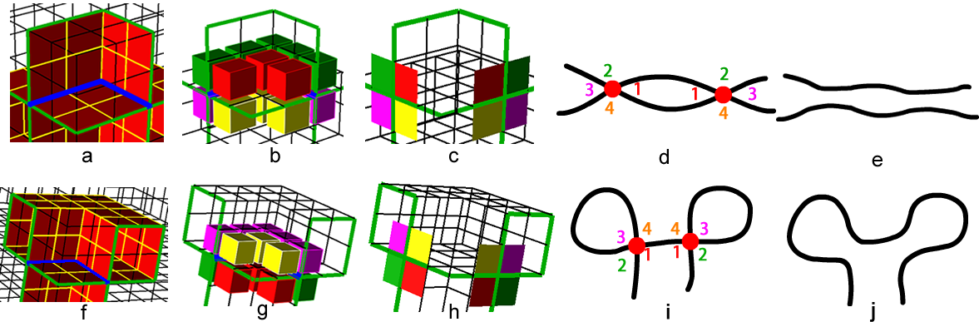Figure 10: Two local intersecting structure for pairing intersecting nodes: (a) the 1st local intersecting quad subset; (b) int-4-hex-sets around the 1st local intersecting quad subset; (c) the 1st local intersecting structure of the boundary loop; (d) the pairing information of the 1st local intersecting structure; (e) the 1st local intersecting structure is resolved for recursive searching; (f) the 2nd local intersecting quad subset; (g) int-4-hex-sets around the 2nd local intersecting the quad subset; (h) the 2nd local intersecting structure of the boundary loop; (i) the pairing information of the 2nd local intersecting structure; (j) the 2nd local intersecting structure is resolved for recursive searching.” (Sec. 3.1)

**Comment 1.12:**

*Line 193-194 "..**.we bring out two templates ..." should be "... we introduce two templates ..."*

**Response:**

The sentence has been revised according to your suggestion.

**Comment 1.13:**

*Line 216-217 "The quads in same color ..." should be "The quads of the same color ..."*

**Response:**

The sentence has been revised according to your suggestion.

**Comment 1.14:**

*Section 3.3, you need to provide a reference for the "max-flow-min-cut" algorithm. I've never heard of this algorithm before, and I thought you were introducing the algorithm. Later, after googling it, I found and studied it to understand. Please provide a reference so we know where to go to get details.*

**Response:**

The reference for the “max-flow-min-cut” algorithm has been added:

“Lawler E. 4.5. combinatorial implications of max-flow min-cut theorem, 4.6. linear programming interpretation of max-flow min-cut theorem. Combinatorial Optimization: Networks and Matroids 2001;:117– 20”

**Comment 1.15:**

*Regarding the "max-flow-min-cut" algorithm, that is a cornerstone of your paper. If people don't understand that algorithm, they will not understand your paper. I recommend you add some more details on that algorithm to people are not required to go look at references to even understand what you are talking about.*

**Response:**

One paragraph has been added to explain what is max-flow, what is min-cut and what the relationship between max-flow and min-cut:

“Max-flow-min-cut algorithm is an effective and efficient tool to find the minimal cut set in a directed graph[18]. On a directed graph with weighted edges, i.e. a flow graph, maximum flow is the maximum amount of flow passing from the source (the s node) to the sink (the t node). And the minimum cut is is a cut (a partition of the vertices of a graph into two disjoint subsets) that is minimal in the sum of weights of the edges in the cut. The max-flow-min-cut theorem states that given a flow graph and s and t nodes, the max-flow equals the min-cut.” (Sec. 3.3)

Meanwhile, we also add reference to the Ford–Fulkerson method which we use to compute the max-flow-min-cut algorithm:

“…The FordFulkerson method is an algo- rithm that can efficiently compute the maximum flow in a flow graph[19]. In this paper, we use the Ford-Fulkeson method to compute the max-flow-min-cut algorithm.”(Sec. 3.3)

**Comment 1.16:**

*Line 285. You have not defined "s node" and "t node". They are defined in the references which talk about "max-flow-min-cut", but you need to define that nomenclature in your paper if you are going to use it.*

**Response:**

We added the brief definition of s node and t node in the paragraph of max-flow-min-cut. S node and t node stand for the source node and sink (or target) node in a flow graph. Please refer to the response to Comment 1.15.

**Comment 1.17:**

*Line 275-276 "...* *into two subsets until reaching ..." should be "... into two subsets before reaching ..."*

**Response:**

The sentence has been revised.

**Comment 1.18:**

*Line 296, you say "... we need to construct the directed graph ...". Later on line 314, you say the graph is* *bi-directional. It cannot be both.*

**Response:**

Yeah, the word “bi-directional” is a bit of confusing. In the directed graph we construct for computing the max-flow-min-cut algorithm, there are only one direction between the “s node” and its adjacent nodes or between “t node” and its adjacent nodes, while there are two oppositely directed edges between other two adjacent nodes. To make it clearer, the sentence “All of the edges in the graph are bi-directional except the edges adjacent to s and t” has been rephrased as:

“There is one directed edge from s node to each of its adjacent nodes. Similarly, there is one directed edge from each of t node’s adjacent nodes to t node. For each pair of adjacent nodes ”

**Comment 1.19:**

*Lines 305-309. It seems that another similar case to this is where you have an edge on the boundary that has only 1 adjacent hex inside the mesh. This could happen on a CAD model edge, but also elsewhere.*

**Response:**

Yes, you are right. This sentence has been rephrased as below:

“…Additionally, mesh edges whose adjacent quads are all boundary quads should not be added into the boundary loop because it usually results in poor mesh quality if the quad set for sheet inflation contains boundary quads. Hence we group the quads sharing these mesh edges into a single node, e.g. q2 and q3 in Fig. 18(c)”(Sec. 3.3)

**Comment 1.20:**

*Section 4.1. You never define what an intersecting line is. You say they are important, and that they must be computed, but you need to add some text to define it (i.e.* *An intersecting line is a piecewise continuous set of edges interior to the hex mesh,* *which connect a pair of intersecting nodes.*

**Response:**

We’ve added definition of intersecting lines in Sec. 3.1:

“For self-intersecting quad sets, the intersecting lines play a very important role in defining the structures of the quad sets. An intersecting line is a piecewise continuous set of edges inte- rior to the hex mesh, which connect a pair of intersecting nodes.” (Sec. 3.1)

and in Sec. 4.1, we’ve also revised the first sentence to explain again what the intersecting lines are:

“Intersecting lines, each of which connect a pair of intersect- ing nodes, are very important for defining the structures of self- intersecting quad sets.” (Sec. 4.1)

**Comment 1.21:**

*Line 361 "The intersecting line is shown in Fig ..." should be "The intersecting line is shown in blue in Fig ..."*

**Response:**

The sentence has been revised.

**Comment 1.22:**

*Lines 420-422 can be made more clear. Please reword to "A mesh edge is called a regular edge if it is inside the mesh and its valence equals 4, or on the boundary of the mesh and its valence equals 3."*

**Response:**

This sentence has been reworded.

**Comment 1.23:**

*Line 550, I think the references should be [9,10], not [11,10].*

**Response:**

The references have been corrected.

**For Reviewer 2:**

**Comment 2.1:**

*The caption of Figure 3 shall be more specific, like "Flowchart of the optimized complex sheet inflation". Moreover, "Step 1:" shall be renamed to "Input:", "Step 2" to "Step 1:", etc.*

**Response:**

Thank you for your comments. The caption of that figure has been revised, and “Step 1:”, “Step 2” and “Step 3” etc. have also been changed according to your suggestion.

**Comment 2.2:**

*Lines 106-109 in Page 2, I recommend authors using numbers rather than letters to list their three major steps, which then will be consistent with Figure 3.*

**Response:**

These letters are changed to numbers.

**Comment 2.3:**

*It is better to include references for the max-flow-min-cut and A* path searching algorithms used in the paper.*

**Response:**

References for max-flow-min-cut and A* path algorithms are added:

“A* path searching is a one-source-one-target path searching algorithm which runs very efficiently[18].”(Sec. 3.1)

“Max-flow-min-cut algorithm is an effective and efficient tool to find the minimal cut set in a directed graph[19].” (Sec. 3.3)

References are:

“[18] HartPE,NilssonNJ,RaphaelB.Aformalbasisfortheheuristicdetermi- nation of minimum cost paths. Systems Science and Cybernetics, IEEE Transactions on 1968;4(2):100–7.

[19] Lawler E. 4.5. combinatorial implications of max-flow min-cut theo- rem, 4.6. linear programming interpretation of max-flow min-cut theo- rem. Combinatorial Optimization: Networks and Matroids 2001;:117– 20.”(Sec. Refences)

**Comment 2.4:**

*In Figure 5, what does "E" denote in the flowchart? In the workflow, if we need to call procedure* *"Find and add new edges to E by max-flow-min-cut algorithm", shall we call procedure* *"Does E satisfy local separation?" again before reach to "End"?*

**Response:**

“E” denotes the constraint mesh edges specified by the user. The sentence has been revised to put it clearer:

“…Suppose E is the specified constraint edges, the flowchart of the determination of

boundary loops is shown in Fig. 9.”(Sec. 3)

After calling "Find and add new edges to E by max-flow-min-cut algorithm", there is no need to check "Does E satisfy local separation?" because the max-flow-min-cut algorithm will guarantee the local separation.

**Comment 2.5:**

*In "3.1. Pairing Intersecton Nodes", how shall we know when we shall apply Template A or Template B? In other words, what is the criterion of using Templates A and B?*

**Response:**

Currently these two local intersecting structures are treated equally, and we use a depth-first strategy to search the boundary loop. We add a sentence in Sec. 3.1 to make it clearer:

“…Currently, we treat these two local intersecting structures equally and use a depth-first strategy to search and handling the two local intersecting structures, which means if we find either local intersecting structure, we pair its two intersecting nodes and resolve it at once until no more intersecting nodes can be handled.” (Sec. 3.1)

However, there may exist a more appropriate strategy to search and handle these two local intersecting structures, and we maybe investigate it in the future.

**Comment 2.6:**

*Lines 231-233 in Page 5, authors say that if there is still one intersecting node left unpaired, they will create a new intersecting node. Is this operation (creating a new intersecting node) manual or automatic?*

**Response:**

This operation is automatic. The two local intersecting structure provide us with enough topological information to find a new intersecting node. We add one sentence in Sec. 3.1 as below:

“…This process can be automatic thanks to the two local intersecting structure which provide us with enough topological information to find the new intersecting node.”(Sec. 3.1)

**Comment 2.7:**

*Line 364 in Page 7, I think it shall be "hex-sets as shown in Fig. 16(c) & (d)".*

**Response:**

It has been corrected.

**Comment 2.8:**

*For Equation (2) in Page 9, it is unclear which "e" is used in "ID(e)"? Shall we use the edge before inflation, after inflation, or the delta between them?*

**Response:**

“e” is the edge before inflation. That’s why we call the process is the “evaluation” for inflating the quad set.

**Comment 2.9:**

*Line 554 in Page 11, I recommend using "hex mesh M_a" and "hex mesh M_b" instead of* *"hex mesh 2" and "hex mesh 1".*

**Response:**

"hex mesh 2" and "hex mesh 1" are changed to "hex mesh 2" and "hex mesh 1" respectively.

**For Reviewer 3:**

**Comment 3.1:**

*While the results are impressive, the readers may have a difficult time understanding the significance of the approach.*

**Response:**

Thank you for your comments. In order to let the readers know better of the significance and motivation of our work, we’ve done three things in this revision: 1) Add one figure and some sentences at the beginning of introduction to show why dual operations are important for mesh modification; 2) Add new figures, examples and paragraphs to explain what sheet inflation is and why it is so useful in mesh modification, especially in boundary modification; 3) add another example to demonstrate why it is necessary to handle generating self-intersecting sheets. For more details, please refer to the response for Comment 1.6.

**Comment 3.2:**

*The authors started the paper with the process of generating sheet inflation in the context of hex meshing. There isn't a definition for "sheet inflation".*

**Response:**

We add a new figure in the introduction to illustrate the procedures of the common dual operations including sheet inflation. Meanwhile we add a new paragraph to explain what sheet inflation is and why the quad set is so important for sheet inflation. Please refer to the response for Comment 1.4 for more details.

**Comment 3.3:**

*When defining the chords using Figure 20, it is not clear whether there are other types of chords and how two chords can be different.*

**Response:**

Theoretically the two kinds of chords mentioned in our paper, one is the chord on a quad mesh and the other is the chord on a quad set for sheet inflation, are the same. They are both retrieved by recursively getting topologically parallel mesh edges on the quads. The only difference between these two kinds of chords is the chord on a quad mesh is not associated to a sheet (because there are no hexahedra) while the chord on a quad set for sheet inflation is associated to a sheet (because it resides inside a hex mesh). Due to the association with a sheet, a chord on the quad set for sheet inflation can be optimized by searching a new path within that sheet to improve the irregular degrees of its edges.

**Comment 3.4:**

*The techniques are clearly explained, and an introduction section at the beginning that clearly describes all relevant definitions and properties about sheets, sheet inflation, chords, intersections, quad sets and their connections to hex remeshing will make this submission self-contained.*

**Response:**

Instead of putting all the definitions into a standalone section, we think putting certain definitions in the place when they are used may be more helpful for the readers to understand the algorithm. So we add the definitions and explanation of sheets, sheet inflation and quad set in the Sec. Introduction. And we put the definition of chords in Sec. 5.2. The connections between dual operations and hex remeshing are demonstrated in Fig. 2.

**Comment 3.5:**

*Moreover, there are relatively few comparisons with existing work, and the models used to demonstrate the techniques are rather simple. For example, how well does the technique work for the Stanford Bunny or Buddha? To fully justify the advantages of the approach, rigorous comparisons will be helpful.*

**Response:**

Our algorithm extends previous sheet inflation algorithms’ ability so that self-intersecting sheets can be locally generated. Self-intersecting sheets are needed to be generated in all the examples in our paper, which cannot be handled by previous sheet inflation algorithms. We add sentences in Sec. Example and Sec. Conclusions and Future Work to explain this difference between our algorithm and previous algorithms:

“…In these three examples, self-intersecting sheets are all required to be locally generated, which cannot be handled by previous sheet inflation algorithms.” (Sec. 6)

“…Compared with previous sheet inflation algorithms, our approach can effectively generate complex sheets within a local region. The examples demonstrate that our approach can locally generate self-intersecting sheets successfully and guarantee the quality of the resultant meshes.” (Sec. 7)

We add a new example of Stanford Bunny to show how our algorithm works on relatively complex models. The example is shown below:

“…We have also tested our algorithm on the hex mesh of the famous Stanford Bunny. In Fig. 35, the hex mesh of Stanford Bunny contains two high-valence boundary nodes. Sheet inflation is conducted to create a self-intersecting sheet to reduce the high node valences. The major procedures are shown in Fig. 36. The modification result in Fig. 37 shows that our algorithm can effectively reduce the high node valences.



Figure 35: Hex mesh of Stanford Bunny with two high-valence boundary nodes.



Figure 36: Process of reducing the high node valences on Stanford Bunny: (a) several boundary edges adjacent to the high-valence nodes are selected as boundary constraints; (b) the boundary loop is constructed; (c) the quad set is constructed; (d) the new sheet is inflated.



Figure 37: The high node valences are reduced by conducting our sheet inflation.

” (Sec. 6)

**Comment 3.3:**

*Lastly, a typo is in "**stands for it valence"; and the sentence "**the main reason for the difficulties is the inherent global connectivity which makes any local modification often .." is incomplete.*

**Response:**

The typo in “stands for it valence” has been fixed, and the sentence has been revised as “The main reason for the difficulties is that local modifications often inevitably propagate to the whole mesh due to the inherent global connectivity[4, 5, 6, 7].”.

**For Reviewer 4:**

**Comment 4.1:**

*Before diving into the details of the review, I'd like to express a consideration on the cover letter accompanying the manuscript. In the "closest prior art" section the authors identify a previous version of the manuscript (rejected at the 24th IMR) as the state of the art in the field. Firstly, I don't think a rejected paper can be counted as state of the art. Secondly, I've found very funny that the manuscript aims to be, at the same time, both state of the art and a novel contribution over the state of the art for hexahedral mesh sheet generation/inflation. This is quite confusing to me.*

**Response:**

Thank you for your comments. The rejected conference paper is written by ourselves. It is required according to the submission guides for author of Computers & Graphics:

“In the Cover Letter, Please

(1) provide a concise summary of the main contributions reported in your submission,

(2) include the full reference and status (submitted, accepted, published) of the closest prior art, including your own, and

(3) clarify how the material reported here differs from that prior art. This information should also be found in the manuscript itself. If a prior submission of your paper has been rejected, you may, if you wish, submit (as accompanying material) a description of what problems or concerns raised by the reviewers you have addressed in this version and how. This information may be particularly useful if we happen to invite a reviewer who has assessed your previous submission.”

( https://www.elsevier.com/journals/computers-and-graphics/0097-8493/guide-for-authors#87000)

**Comment 4.2:**

*As far as I understand the novelty of your approach is the ability to handle inflation sheets that self-intersect more than once. What I think is missing is: why self-intersecting sheets are important, and, in what your method is superior to previous methods like e.g. [9] and [10]? Can you show a practical example in which previous methods would fail because they do not handle self-intersecting sheets whereas your method would succeed? Furthermore, the application proposed in Section 6.1 is not quite clear to me; I had to download and read both [10] and [11] to figure out what mesh matching is about. The associated figures don't really help to understand (the wireframe images are almost impossible to read).*

**Response:**

Compared with existing work, our approach can generate sheets that self-intersect more than once and localize the modification. The ability to generate self-intersecting sheets is quite desirable when doing complex mesh modification on the mesh boundary.

//还没写好。。

**Comment 4.3:**

*Figure 3 is not very clear as well. It took me a while to spot the difference between step 1 and step 2; I'd suggest to use a different color and maybe a closeup to show the portion of curve that closes the loop. The wireframe shading in step 2 is also very difficult to interpret. The difference between step 3 and 4 is not clear as well; I can see two slightly different quad sets but I don't understand nothing more than this: why the optimized quad set is better than the non-optimized one? I guess in the optimized quad set the overall valence of the edges is lower, but the picture shows none of this. Can you visualize it?*

**Response:**

The portion of curve that closes the loop has been highlighted and denoted. The whole figure has been scaled in order to make the figure easier to understand. The optimized quad set are better because it has lower irregular degrees of the edges. The irregular degrees of the quad set before and after optimization are explicitly shown in the figure now, which may be clearer than visualization, because there are many irregular edges and some irregular edges are obscured by the quad set. The modified figure is shown below:

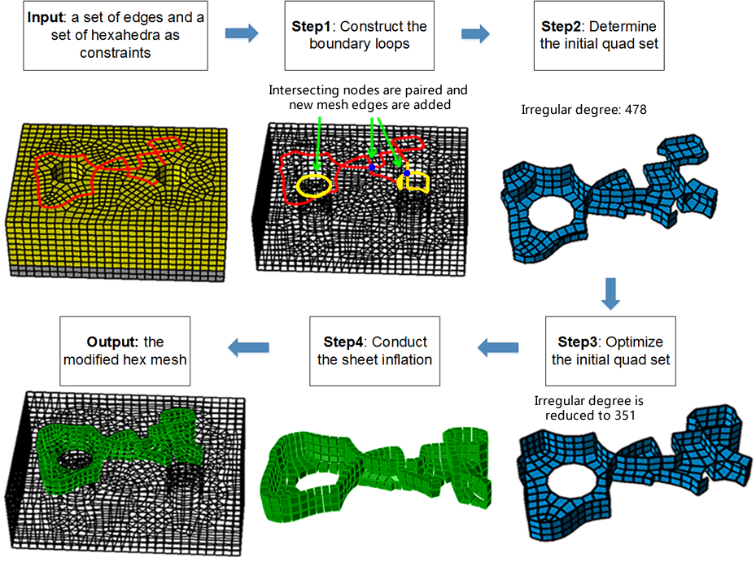

**Comment 4.4:**

*I don't understand why the algorithm is restricted only to loops. It seems to me that a quad set that traverses a shape from left to right separating it in two connected components (or more, if intersecting nodes are present) is a valuable solution in many cases. Am I wrong? Am I missing anything?*

**Response:**

Sorry for not explaining the motivation of our work clear. In many mesh modification scenarios, the user only wants to locally modify the boundary of a hex mesh. Although the quad set is very important for sheet inflation (the process of sheet inflation and why the quad set is so important for sheet inflation has been explained in the introduction), it is neither necessary nor convenient for the user to select the quad set directly. So a more instinct way is to let the user select a set of boundary mesh edges as constraint to guide the determination of the quad set. The algorithm in our paper actually provides a solution for constructing the quad set under the user-specified constraints. We add new examples to explain our motivation in the introduction. Please refer to the response for Comment 1.6.

**Comment 4.5:**

*The same goes for a loop with a single intersecting node. Is there any specific reason why this solution is not good? Is it a bad solution for applications or it's your method that cannot handle such case because it does not fit your templates? This is not very clear to me.*

**Response:**

It the loop with a single intersecting node is not closed, we can automatically create another intersecting node to pair with it. However, it is impossible to construct a quad set for sheet inflation from a single closed loop with one intersecting node, because an intersecting line can only have 0 or 2 intersecting nodes. An odd number of intersecting nodes on the loop is invalid for constructing the quad set for sheet inflation. We’ve revised a sentence in Sec. 3 when describing the characteristics of an inflatable quad set and its boundary loop:

“…The second characteristic also indicates that each intersecting node on the boundary loop needs another intersecting node to be paired in order to determine an intersecting line, which means there should be an even number of intersecting nodes. An odd number of intersecting nodes on the boundary loop is invalid for constructing the quad set for sheet inflation.” (Sec. 3)

**Comment 4.6:**

*Despite the length of the paper (13 pages) there are not enough technical details. I don't think a student would be able to reproduce your results based on the content of the manuscript. The formalization of both the min-cut and A* problems is missing. Furthermore, how do you edit A* to consider turning angles? Please provide citations and/or an explanation of how you formalize your problems, what are the unknowns and how do you solve for them.*

**Response:**

For max-flow-min-cut algorithm, we’ve added more sentences in our paper to explain the background of this algorithm and corresponding references. We use Ford-Fulkerson method to calculate the max-flow-min-cut problem. Reference of Ford-Fulkerson method has also been added. We also provide detailed information about how to construct the directed graph. The new and revised sentences are shown below:

“Max-flow-min-cut algorithm is an effective and efficient tool to find the minimal cutset in a directed graph[20]. On a directed graph with weighted edges, i.e. a flow graph, maximum flow is the maximum amount of flow passing from the source (the s node) to the sink (the t node). And the minimum cut is is a cut (a partition of the vertices of a graph into two disjoint subsets) that is minimal in the sum of weights of the edges in the cut. The max-flow-min-cut theorem states that given a flow graph and s and t nodes, the max-flow equals the min-cut.

As shown in Fig. 20(a), to use the max-flow-min-cut algorithm, a directed graph should be constructed with an s node and a t node, and the weights of the edges should also be set before calculation. The algorithm will find a minimal cut set that determines the max flow from s to t.

If we take the boundary of H as a graph where the nodes stand for a quad or a quad set and the edges stand for the adjacency relationship between the quads or quad sets, then to be able to do local separation is similar to find a cut set on this graph. Hence, the max-flow-min-cut algorithm can be used to help us to find necessary edges to make the boundary loop satisfy the local separation. The Ford-Fulkerson method is an algorithm that can efficiently compute the maximum flow in a flow graph[21]. In this paper, we use the Ford-Fulkeson method to compute the max-flow-min-cut algorithm.” (Sec. 3.3)

For A* algorithm, to formally explain how we apply this algorithm, we add new figures, paragraphs and references:

“A* path searching is a one-source-one-target path searching algorithm which runs very e_ciently[18]. It is an extension of the Dijkstra’s algorithm[19]. The formalization of A* algorithm is shown in Equ. 1. Here, g(n) is the known cost of getting from the initial node to n; this value is tracked by the algorithm. h(n) is a heuristic estimate of the cost to get from n to the target node. For the algorithm to find the actual shortest path, the heuristic function h(n) should never overestimate the actual cost to get to the target node.

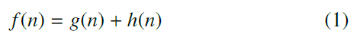

Given two boundary mesh edges e1 and e2 and their common mesh node v, e1 and e2 separate v’s adjacent quads into to quad subsets Q1 and Q2. The turning angle in this paper is the quad number variance between these two quad subsets, which can be calculated by Equ. 2 where ||Q1|| and ||Q2|| stand for the number of quads in Q1 and Q2 respectively.

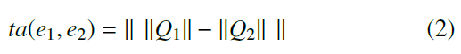

For example in Fig. 15a, Q1 and Q2 contain 1 and 3 quads respectively. So ta(e1; e2) = 2. In Fig. 15b, Q1 and Q2 both contain 2 quads. So ta(e1; e2) = 0.

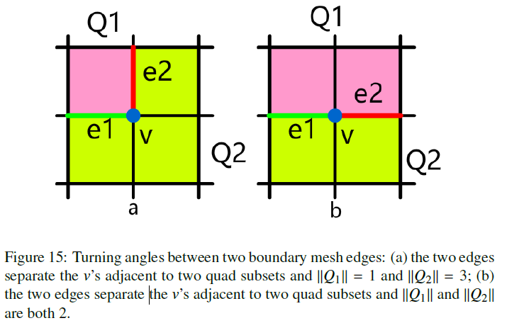

When applying A* algorithm, in addition to considering the count of mesh edges on the path, we also take the angles between adjacent edges on the path into consideration. This is necessary because if the turning angles are large, the mesh quality, especially the boundary mesh quality, will degenerate. Therefore, suppose the current mesh edges are E, the determined part in A* algorithm can be calculated using Equ. 3 where ||E|| stands for the number of edges in E. The weight  controls the magnitude of how the turning angle impacts on the searching result. Usually  = 1 is feasible.

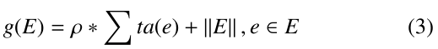

For the heuristic part of A*, we use a breadth-first strategy to estimate at least how many mesh edges are needed to be traversed from current node to the target node. Since the breadth-first estimation only takes the number of traversed edges into consideration, it meets the requirement in A* algorithm that h(n) should never overestimate the actual cost to get to the target node. For example after conducting a breadth-first iteration, the minimum numbers of mesh edges that are needed to be traversed from a given mesh node to v1are shown in Fig. 16a. Therefore h(v2)= 2 and h(v3)= 4.

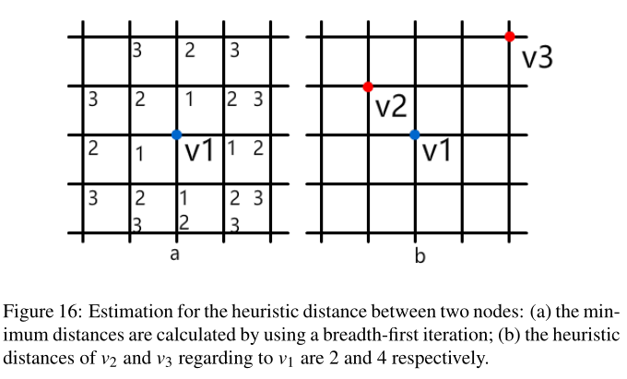

” (Sec. 3.2)

**Comment 4.7:**

*From the abstract: "it is still difficult to generate self-intersecting sheet within a local region while assuring the mesh quality." and "Our approach can generate complex sheets that intersect themselves more than once and guarantee the quality of the resultant mesh" - Mesh quality is a quite vague concept; there are different metrics to measure quality, and the definition you stick to is just one among many other possible definitions. Please either rephrase or be more precise.*

**Response:**

Yes, there are many different metrics to measure quality of a quad set or a sheet. To explicitly tell the readers how we measure the quality, we add a sentence in the introduction as below:

“…Since the edge valences (the number of quads that are adjacent to one edge) have significant impact on the mesh quality [15], we use the irregular degrees (the edge’s valence variance from a regular edge)[17] to measure the quality of the quad set.” (Sec. Introduction)

Finally, it is our pleasure to have our paper being considered to publish in Computers & Graphics. Please do not hesitate to contact us if you need further information or work.

Sincerely yours,

The authors